In cell fractionation, various components of cells including its organelles can be isolated in different layers depending upon:
A. Their physical properties like size & weight.
B. Physical properties of the medium like its density.
C. Their electrical properties like their charges
D. Both A and B
ANSWER: D
What is called centrifugation?
A. Separated through spinning
B. Separate components at higher temperature
C. Separate components at lower temperature
D. Separated through evaporation
ANSWER: A
________ is the process to separate substances on the basis of their size and densities under the influence of centrifugal force
A. Centrifugation
B. Tissue culture
C. Spectrophotometry
D. Electrophoresis
ANSWER: A
There are __________ major ways of centrifugation
A. 6
B. 2
C. 7
D. 3
ANSWER: B
In __________the cell components of different sizes and densities are separated in different layers.
A. differential centrifugation
B. density gradient centrifugation
C. both a and b
D. none of these
ANSWER: B
In ___________the size and shape of particles determines how fast it settles.
A. differential centrifugation
B. density gradient centrifugation
C. both a and b
D. none of these
ANSWER: A
____________ denote the liquid lying above a solid residue after centrifugation
A. supernatant
B. Pallet
C. both a and b
D. none of these
ANSWER: A
Microscope is used to assist in dissection
A. microdissection
B. Tissue culture
C. Spectrophotometry
D. Electrophoresis
ANSWER: A
__________is the cultivation of plant cells, tissues, or organs on specially formulated nutrient media
A. microdissection
B. Tissue culture
C. Spectrophotometry
D. Electrophoresis
ANSWER: B
___________uses photometers, known as spectrophotometers, that can measure the intensity of a light beam at different wavelengths
A. microdissection
B. Tissue culture
C. Spectrophotometry
D. Electrophoresis
ANSWER: C
__________is a laboratory technique used to separate DNA, RNA or protein molecules based on their size and electrical charge
A. microdissection
B. Tissue culture
C. Spectrophotometry
D. Electrophoresis
ANSWER: D
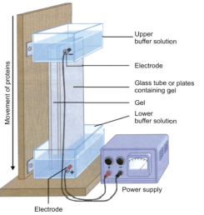
Identify the technique used in cell biology
A. microdissection
B. tissue culture
C. spectrophotometry
D. gel electrophoresis
ANSWER: D
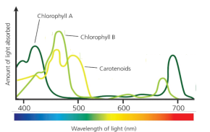
The diagram is of:
A. gel electrophoresis
B. tissue culture
C. absorption spectrum
D. microdissection
ANSWER: C
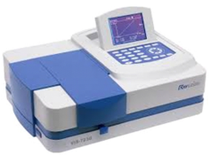
The picture is of:
A. microdissection
B. Spectrophotometer
C. gel electrophoresis
D. tissue culture
ANSWER: B
Paper chromatography involves:
A. 5 phases
B. 2 phases
C. 6 phases
D. 8 phases
ANSWER: B

